**Java Program to Print Star Pattern, Pattern of Stars (*)**

This article is created to cover a lot of pattern programs using star (*) in Java. This article covers all the famous pattern programs using star. More than 15 pattern programs using star, are included in this article.

**Print Star Pattern in Java - Pattern No.1**

The question is, *write a Java program to print star pattern.* The program given below is its answer:

public class CodesCracker

{

public static void main(String[] args)

{

int i, j;

for(i=0; i<5; i++)

{

for(j=0; j<=i; j++)

{

System.out.print("* ");

}

System.out.print("\n");

}

}

}

The snapshot given below shows the sample output produced by above program in Java, on printing of star (*) pattern:

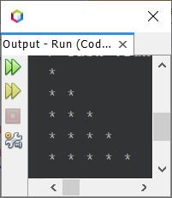

import java.util.Scanner;

public class CodesCracker

{

public static void main(String[] args)

{

int row, i, j;

Scanner s = new Scanner(System.in);

System.out.print("Enter the Number of Lines (Row): ");

row = s.nextInt();

for(i=0; i<row; i++)

{

for(j=0; j<=i; j++)

System.out.print("* ");

System.out.print("\n");

}

}

}

The sample run of above program with user input **10** as number of lines/rows to expand the pattern, is given in the following snapshot:

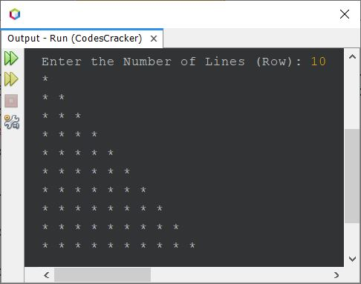

You can use the same, to allow user to define the size of row/line to expand the pattern, in any program given here.

**Print Star Pattern in Java - Pattern No.2**

public class CodesCracker

{

public static void main(String[] args)

{

int row=5, i, j, space, spaceLimit;

spaceLimit = (row*2) - 2;

for(i=0; i<row; i++)

{

for(space=0; space<spaceLimit; space++)

System.out.print(" ");

for(j=0; j<=i; j++)

System.out.print("* ");

System.out.print("\n");

spaceLimit = spaceLimit-2;

}

}

}

The output of above program is:

*

* *

* * *

* * * *

* * * * *

Also the above program can also be created in this way, to allow user to define the size of the pattern:

import java.util.Scanner;

public class CodesCracker

{

public static void main(String[] args)

{

int row, i, j, space, spaceLimit;

Scanner s = new Scanner(System.in);

System.out.print("Enter the Row Size of Pattern: ");

row = s.nextInt();

spaceLimit = (row*2) - 2;

for(i=0; i<row; i++)

{

for(space=0; space<spaceLimit; space++)

System.out.print(" ");

for(j=0; j<=i; j++)

System.out.print("* ");

System.out.print("\n");

spaceLimit = spaceLimit-2;

}

}

}

The sample run of above program with user input **15** is shown in the snapshot given below:

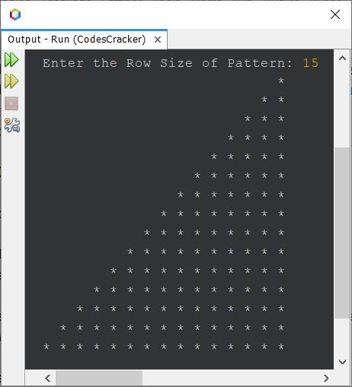

You can apply the same in other programs too, to print the specified size of pattern by user at run-time of the program.

**Print Star Pattern in Java - Pattern No.3**

public class CodesCracker

{

public static void main(String[] args)

{

int row=5, i, j;

for(i=0; i<row; i++)

{

for(j=i; j<row; j++)

System.out.print("* ");

System.out.print("\n");

}

}

}

**Output of Pattern No.3 Program**

* * * * *

* * * *

* * *

* *

*

**Print Star Pattern in Java - Pattern No.4**

public class CodesCracker

{

public static void main(String[] args)

{

int row=5, i, j, space, spaceLimit=0;

for(i=0; i<row; i++)

{

for(space=0; space<spaceLimit; space++)

System.out.print(" ");

for(j=i; j<row; j++)

System.out.print("* ");

System.out.print("\n");

spaceLimit = spaceLimit + 2;

}

}

}

**Output of Pattern No.4 Program**

* * * * *

* * * *

* * *

* *

*

**Print Star Pattern in Java - Pattern No.5**

class CodesCracker

{

public static void main(String[] args)

{

int i, j, row=10;

for(i=0; i<row; i++)

{

for(j=0; j<=i; j++)

{

if(i==0 || i==1)

System.out.print("* ");

else if(i==(row-1))

System.out.print("* ");

else

{

if(j==0 || j==i)

System.out.print("* ");

else

System.out.print(" ");

}

}

System.out.print("\n");

}

}

}

**Output of Pattern No.5 Program**

*

* *

* *

* *

* *

* *

* *

* *

* *

* * * * * * * * * *

**Print Star Pattern in Java - Pattern No.6**

public class CodesCracker

{

public static void main(String[] args)

{

int i, j, row=10, space, spaceLimit;

spaceLimit = (row*2) - 2;

for(i=0; i<row; i++)

{

for(space=0; space<spaceLimit; space++)

System.out.print(" ");

for(j=0; j<=i; j++)

{

if(i==0 || i==1)

System.out.print("* ");

else if(i==(row-1))

System.out.print("* ");

else

{

if(j==0 || j==i)

System.out.print("* ");

else

System.out.print(" ");

}

}

System.out.print("\n");

spaceLimit = spaceLimit - 2;

}

}

}

**Output of Pattern No.6 Program**

*

* *

* *

* *

* *

* *

* *

* *

* *

* * * * * * * * * *

**Print Star Pattern in Java - Pattern No.7**

public class CodesCracker

{

public static void main(String[] args)

{

int i, j, row=10;

for(i=0; i<row; i++)

{

for(j=i; j<row; j++)

{

if(i==0 || i==(row-1) || i==(row-2))

System.out.print("* ");

else

{

if(j==i || j==(row-1))

System.out.print("* ");

else

System.out.print(" ");

}

}

System.out.print("\n");

}

}

}

**Output of Pattern No.7 Program**

* * * * * * * * * *

* *

* *

* *

* *

* *

* *

* *

* *

*

**Print Star Pattern in Java - Pattern No.8**

public class CodesCracker

{

public static void main(String[] args)

{

int i, j, row=10, space, spaceLimit=0;

for(i=0; i<row; i++)

{

for(space=0; space<spaceLimit; space++)

System.out.print(" ");

for(j=i; j<row; j++)

{

if(i==0 || i==(row-1) || i==(row-2))

System.out.print("* ");

else

{

if(j==i || j==(row-1))

System.out.print("* ");

else

System.out.print(" ");

}

}

System.out.print("\n");

spaceLimit += 2;

}

}

}

**Output of Pattern No.8 Program**

* * * * * * * * * *

* *

* *

* *

* *

* *

* *

* *

* *

*

**Print Star Pattern in Java - Pattern No.9**

public class CodesCracker

{

public static void main(String[] args)

{

int i, j, row=10, space;

for(i=0; i<row; i++)

{

for(space=i; space<row; space++)

System.out.print(" ");

for(j=0; j<=i; j++)

System.out.print("* ");

System.out.print("\n");

}

}

}

**Output of Pattern No.9 Program**

*

* *

* * *

* * * *

* * * * *

* * * * * *

* * * * * * *

* * * * * * * *

* * * * * * * * *

* * * * * * * * * *

**Print Star Pattern in Java - Pattern No.10**

public class CodesCracker

{

public static void main(String[] args)

{

int i, j, row=10, space;

for(i=0; i<row; i++)

{

for(space=i; space<row; space++)

System.out.print(" ");

for(j=0; j<=i; j++)

{

if(i==0 || i==1)

System.out.print("* ");

else if(i==(row-1))

System.out.print("* ");

else

{

if(j==0 || j==i)

System.out.print("* ");

else

System.out.print(" ");

}

}

System.out.print("\n");

}

}

}

**Output of Pattern No.10 Program**

*

* *

* *

* *

* *

* *

* *

* *

* *

* * * * * * * * * *

**Print Star Pattern in Java - Pattern No.11**

public class CodesCracker

{

public static void main(String[] args)

{

int i, j, row=10, space;

for(i=0; i<row; i++)

{

for(space=0; space<i; space++)

System.out.print(" ");

for(j=i; j<row; j++)

System.out.print("* ");

System.out.print("\n");

}

}

}

**Output of Pattern No.11 Program**

* * * * * * * * * *

* * * * * * * * *

* * * * * * * *

* * * * * * *

* * * * * *

* * * * *

* * * *

* * *

* *

*

**Print Star Pattern in Java - Pattern No.12**

public class CodesCracker

{

public static void main(String[] args)

{

int i, j, row=10, space;

for(i=0; i<row; i++)

{

for(space=0; space<i; space++)

System.out.print(" ");

for(j=i; j<row; j++)

{

if(i==0 || i==(row-1) || i==(row-2))

System.out.print("* ");

else

{

if(j==i || j==(row-1))

System.out.print("* ");

else

System.out.print(" ");

}

}

System.out.print("\n");

}

}

}

**Output of Pattern No.12 Program**

* * * * * * * * * *

* *

* *

* *

* *

* *

* *

* *

* *

*

**Print Star Pattern in Java - Pattern No.13**

public class CodesCracker

{

public static void main(String[] args)

{

int i, j, row=7;

for(i=0; i<row; i++)

{

for(j=i; j>=0; j--)

System.out.print("* ");

System.out.print("\n");

}

for(i=0; i<(row-1); i++)

{

for(j=(row-1); j>i; j--)

System.out.print("* ");

System.out.print("\n");

}

}

}

**Output of Pattern No.13 Program**

*

* *

* * *

* * * *

* * * * *

* * * * * *

* * * * * * *

* * * * * *

* * * * *

* * * *

* * *

* *

*

Above program can also be written as following program. This program shows the actual use of row. That is, in above program, the value of **row** is given 7, but the pattern expanded upto 13 lines. Therefore, we need to modify that program:

public class CodesCracker

{

public static void main(String[] args)

{

int i, j, row=13, decider;

if(row%2==0)

decider = row/2;

else

decider = (row/2) + 1;

for(i=0; i<row; i++)

{

if(i<decider)

{

for(j=i; j>=0; j--)

System.out.print("* ");

}

else

{

for(j=i; j<row; j++)

System.out.print("* ");

}

System.out.print("\n");

}

}

}

It will produces the same output as shown in the snapshot given below:

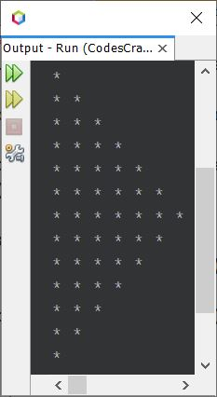

**Note -**You can do a lot of modification in any of the program given here, to improve your concept. Because, the same program can be created in multiple ways.

**Print Star Pattern in Java - Pattern No.14**

public class CodesCracker

{

public static void main(String[] args)

{

int i, j, row=13, decider;

if(row%2==0)

decider = row/2;

else

decider = (row/2) + 1;

for(i=0; i<row; i++)

{

if(i<decider)

{

for(j=i; j>=0; j--)

{

if(i==0 || i==1)

System.out.print("* ");

else if(j==i || j==0)

System.out.print("* ");

else

System.out.print(" ");

}

}

else

{

for(j=i; j<row; j++)

{

if(i==(row-1) || i==(row-2))

System.out.print("* ");

else if(j==i || j==(row-1))

System.out.print("* ");

else

System.out.print(" ");

}

}

System.out.print("\n");

}

}

}

**Output of Pattern No.14 Program**

*

* *

* *

* *

* *

* *

* *

* *

* *

* *

* *

* *

*

**Print Star Pattern in Java - Pattern No.15**

public class CodesCracker

{

public static void main(String[] args)

{

int i, j, row=7, space, spaceLimit;

spaceLimit = (row*2) - 2;

for(i=0; i<row; i++)

{

for(space=0; space<spaceLimit; space++)

System.out.print(" ");

for(j=0; j<=i; j++)

System.out.print("* ");

System.out.print("\n");

spaceLimit -= 2;

}

spaceLimit = 0;

for(i=0; i<(row-1); i++)

{

for(space=i; space<=spaceLimit; space++)

System.out.print(" ");

for(j=(row-1); j>i; j--)

System.out.print("* ");

System.out.print("\n");

spaceLimit += 2;

}

}

}

**Output of Pattern No.15 Program**

*

* *

* * *

* * * *

* * * * *

* * * * * *

* * * * * * *

* * * * * *

* * * * *

* * * *

* * *

* *

*

**Print Star Pattern in Java - Pattern No.16**

public class CodesCracker

{

public static void main(String[] args)

{

int i, j, row=7, space, spaceLimit;

spaceLimit = (row*2) - 2;

for(i=0; i<row; i++)

{

for(space=0; space<spaceLimit; space++)

System.out.print(" ");

for(j=0; j<=i; j++)

{

if(i==0 || i==1)

System.out.print("* ");

else

{

if(j==0 || j==i)

System.out.print("* ");

else

System.out.print(" ");

}

}

System.out.print("\n");

spaceLimit -= 2;

}

spaceLimit = 0;

for(i=0; i<(row-1); i++)

{

for(space=i; space<=spaceLimit; space++)

System.out.print(" ");

for(j=(row-1); j>i; j--)

{

if(i==(row-2) || i==(row-3))

System.out.print("* ");

else

{

if(j==(row-1) || j==(i+1))

System.out.print("* ");

else

System.out.print(" ");

}

}

System.out.print("\n");

spaceLimit += 2;

}

}

}

**Output of Pattern No.16 Program**

*

* *

* *

* *

* *

* *

* *

* *

* *

* *

* *

* *

*

**Print Star Pattern in Java - Pattern No.17**

From any pattern given above, you can also combine any two to create another pattern, like shown in the program and its sample output given below:

public class CodesCracker

{

public static void main(String[] args)

{

int i, j, row=10, space;

for(i=0; i<row; i++)

{

for(space=0; space<i; space++)

System.out.print(" ");

for(j=i; j<row; j++)

System.out.print("* ");

System.out.print("\n");

}

for(i=0; i<row; i++)

{

for(space=(i+1); space<row; space++)

System.out.print(" ");

for(j=0; j<=i; j++)

System.out.print("* ");

System.out.print("\n");

}

}

}

**Output of Pattern No.17 Program**

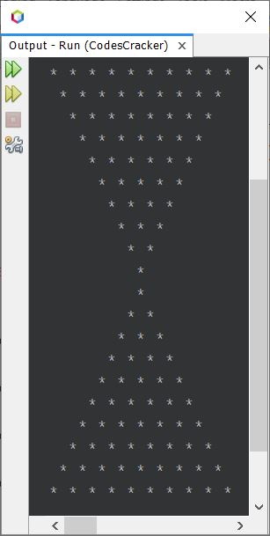

**Print Star Pattern in Java - Pattern No.18**

Here is another and last pattern of stars, I'm going to create for this article.

public class CodesCracker

{

public static void main(String[] args)

{

int i, j, k=1, row=5;

for(i=0; i<row; i++)

{

for(j=0; j<k; j++)

System.out.print("* ");

k += 2;

System.out.print("\n");

}

}

}

**Output of Pattern No.18 Program**

*

* * *

* * * * *

* * * * * * *

* * * * * * * * *

**Note -**There are tons of pattern you can try with. These programs are just demo, to show you, how the code can be written in Java, to design different - different star pattern. Still you can design the pattern in your mind and implement that pattern in programming world. Do it yourself. For sure, it will boost your logic.